CONSULATE-GENERAL OF JAPAN
Suite 3300, 77 King Street West, Toronto, Ontario, Canada M5K 1A1
Telephone: (416) 363-7038 Fax: (416) 363-6074 E-mail: access@to.mofa.go.jp

Media Release

Embargoed until Nov. 3, 2015

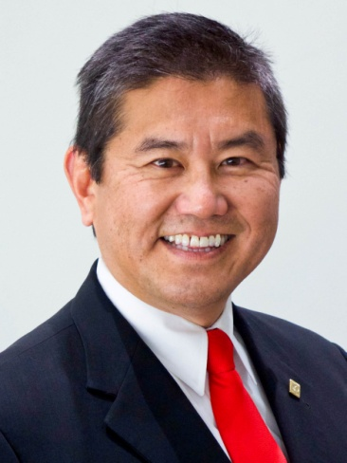

Conferral of the Order of the Rising Sun, Gold and Silver Rays, upon the Former President of the Japanese Canadian Cultural Centre,
Marty Blake Kobayashi

On November 3, 2015 (Japan Standard Time), the Government of Japan announced the foreign recipients of the 2015 Autumn Imperial Decorations. Among the 89 foreign recipients is former President of the Japanese Canadian Cultural Centre, Marty Blake Kobayashi, who will receive the Order of the Rising Sun, Gold and Silver Rays in recognition of his outstanding contributions toward promoting Japanese Culture in Canada, strengthening and deepening friendship between Japan and Canada and consolidating the Japanese Canadian community. Upon the announcement, Fumio Kishida, the Minister for Foreign Affairs of Japan sent a congratulatory message to Mr. Kobayashi. A ceremony for bestowal of the decoration will be held in due course in Toronto.

Martin Kobayashi has taken an active role in operating the Japanese Canadian Cultural Centre (JCCC) as a member of the board of directors for thirty-two years. During his twelve year tenure as the President of the JCCC, Marty Kobayashi has demonstrated his strong leadership by successfully organizing a large number of cultural events to promote Japanese culture, and strengthened the unity of the Japanese Canadian community as a result. Even after completing his role as the President of the JCCC in 2009, he continues to passionately get involved in various activities for the Japanese Canadian community to this date.
- DECORATION: The Order Rising Sun, Gold and Silver Rays
- SERVICE: Contributed to promoting Japanese Culture in Canada, to strengthening and deepening the friendship between Japan and Canada and to consolidating the Japanese Canadian Community through the long years of his deep involvement with the community, especially during his twelve year tenure as the President of the Japanese Canadian Cultural Centre.
- NAME: Marty Blake Kobayashi
- TITLES: Former President of the Japanese Canadian Cultural Centre
Contribution to Japan
Marty Kobayashi tenured as the President of the JCCC for twelve years, and as a chief executive, he took a leadership role in organizing the JCCC’s various activities such as promoting Japanese culture and cultural exchange between Japan and Canada. Through this interaction of people from Japan and Canada, Marty Kobayashi played a major role in building stronger ties of friendship between Japan and Canada, and strengthened the unity of the Japanese Canadian community. His detailed planning and execution of projects can be credited to the success of Their Majesty the Emperor and Empress of Japan’s visit to the JCCC in 2009, and the Japanese Canadian Community Centre’s 25th Anniversary Gala dinner.

Contribution to Promoting Japanese Culture
Marty Kobayashi’s project “Tokyo Pavilion” at the Toronto International Festival Caravan was a tremendously successful installation from which to promote Japanese culture, and it increased the knowledge of and interest in Japan among Canadian people. The success of the Tokyo Pavilion led to a significant increase in membership applications at the JCCC, as well as in the number of participants at their martial arts and cultural lectures. He also became a representative of the group “Toronto Suwa Daiko”, established in 1981, to promote traditional Japanese music. (Toronto Suwa Daiko plays the traditional Japanese drum called Taiko)

Contribution to the Japanese and Canadian Network Organization (JCNO)
Marty Kobayashi was the Chairman of the Japanese and Canadian Network Organization (JCNO). In this role, he took great initiative to achieve mutual understanding between Japanese Canadian and other Japanese groups in order to build a strong cooperative structure within the Japanese community as a whole.

Media contact: Rui Umezawa – rui.umezawa@to.mofa.go.jp

